1. Maak een Azure SQL Server en Azure sql database aan met als naam CustomerDB
2. Volg de stappen in bijlage 1 om AAD te enablen met je SQL Server
3. Zorg ervoor dat je client ip adres connectie mag maken met de SQL server
4. Maak verbinding met Azure SQL Server via SQL Server management studio.
5. Voer het script uit van bijlage 2
6. Creëer de tabel customer in je aangemaakte customerDB database door bijlage 3 uit te voeren
7. Voeg de AAD groep accountmanagers Nederland toe aan de tabel en voer als country “NL” op. Doe dit ook voor accountmanagers USA en voer hier USA op als country.  
   Voer ook de groep commercieel directeur op en zorg dat deze beide landen mag zien.
8. Vervolgens: maak een security functie die op basis van een land bepaalt wie deze waarde mag zien. Zie bijlage 4

# Bijlage 1

The following two procedures show you how to provision an Azure Active Directory administrator for your Azure SQL server in the Azure portal and by using PowerShell.+

Azure portal

1. In the [Azure portal](https://portal.azure.com/), in the upper-right corner, click your connection to drop down a list of possible Active Directories. Choose the correct Active Directory as the default Azure AD. This step links the subscription association with Active Directory with Azure SQL server making sure that the same subscription is used for both Azure AD and SQL Server. (The Azure SQL server can be hosting either Azure SQL Database or Azure SQL Data Warehouse.)

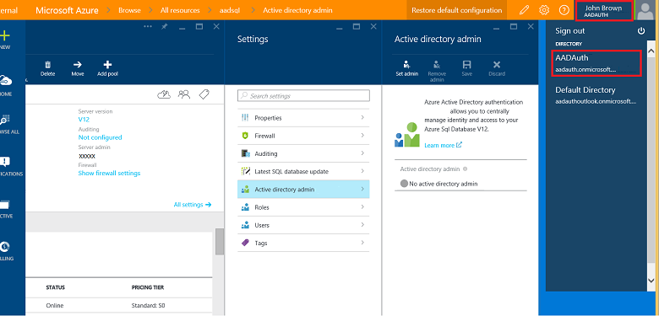

1. In the left banner select **SQL servers**, select your **SQL server**, and then in the **SQL Server** blade, at the top click **Settings**.

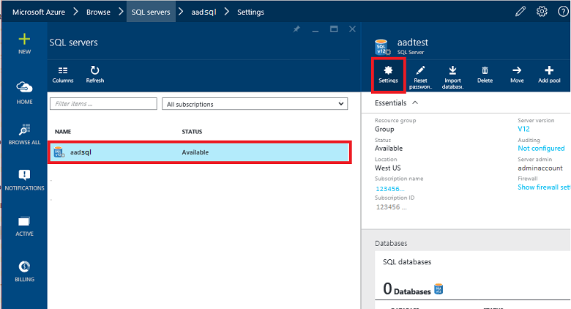

1. In the **Settings** blade, click **Active Directory admin**.
2. In the **Active Directory admin** blade, click **Active Directory admin**, and then at the top, click **Set admin**.
3. In the **Add admin** blade, search for a user, select the user or group to be an administrator, and then click **Select**. (The Active Directory admin blade shows all members and groups of your Active Directory. Users or groups that are grayed out cannot be selected because they are not supported as Azure AD administrators. (See the list of supported admins in **Azure AD Features and Limitations** above.) Role-based access control (RBAC) applies only to the portal and is not propagated to SQL Server.
4. At the top of the **Active Directory admin** blade, click **SAVE**.

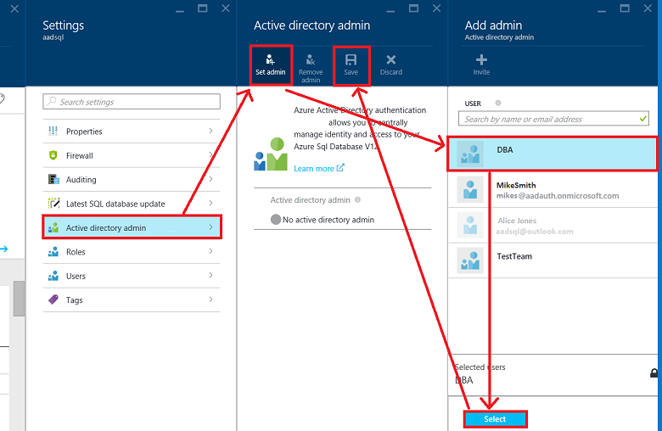

The process of changing the administrator may take several minutes. Then the new administrator appears in the **Active Directory admin** box.

Note

When setting up the Azure AD admin, the new admin name (user or group) cannot already be present in the virtual master database as a SQL Server authentication user. If present, the Azure AD admin setup will fail; rolling back its creation and indicating that such an admin (name) already exists. Since such a SQL Server authentication user is not part of the Azure AD, any effort to connect to the server using Azure AD authentication fails.

+

To later remove an Admin, at the top of the **Active Directory admin** blade, click **Remove admin**, and then click **Save**.Bijlage 2  
Create user [sql test cloud] from external provider

SELECT * FROM sys.sysusers;

ALTER ROLE db_datareader ADD MEMBER [sql test cloud]

GO

# Bijlage 3

create table customer

(

id int identity(1,1) primary key

, [name] varchar(500)

, country varchar(100)

, omzet int

)

Voer data in :   
  
USE [CustomerDB]

GO

INSERT INTO [dbo].[customer]

([name]

,[country]

,[omzet])

VALUES

('John'

,'USA'

,1000),

('Kees'

,'NL'

,1500)

,('Kim'

,'USA'

,11000),

('Meneer van Dalen'

,'NL'

,-100),

('Sanne'

,'NL'

,100000)

GO

Creeer een tabel voor rechten  
  
  
create table userrights

(

id int identity(1,1) primary key

, AADGroep varchar(300)

, country varchar(100)  
)

# Bijlage 4

Create Function dbo.fn_securitypredicateCountry (@country varchar(100))

returns table

with Schemabinding

as

return select 1 as [fn_securityPredicateCountryresult]

from dbo.userrights rr

where( is_member(rr.AADGroep) = 1

and rr.country = @country

)

Als laatste, geef aan dat de volgende tabel op country moet worden gefilterd:

CREATE SECURITY POLICY [dbo].[fn_security]

ADD FILTER PREDICATE dbo.fn_securitypredicateCountry([country]) ON dbo.[customer]

WITH (STATE = ON);